# GOVERNMENT ARTS AND SCIENCE COLLEGE

# SRIVILLIPUTTUR

# 1.Introduction

Estimating business expenses is a crucial aspect of financial planning and management for any organization, whether it's a small startup or a large multinational corporation. These estimates play a fundamental role in helping businesses make informed decisions, set budgets, and ensure the efficient allocation of resources. The process of estimating business expenses involves forecasting the costs associated with various operational activities, such as production, marketing, administration, and more. It serves as the foundation for financial stability and sustainability, enabling companies to navigate uncertainties, adapt to changing market conditions, and achieve their long-term goals.

# 1.1.Overview:

1. **Purpose of Expense Estimation**: The primary purpose of estimating business expenses is to gain insight into the financial obligations and resource requirements necessary to operate a business. This process is crucial for budgeting, setting financial goals, and ensuring that a company's revenue exceeds its costs.
2. **Types of Expenses**: Business expenses can be categorized into two main types:
   * **Fixed Expenses**: These are regular, predictable costs that remain relatively constant, such as rent, salaries, insurance, and lease payments.
   * **Variable Expenses**: These costs fluctuate depending on factors like production levels, sales, and market conditions. Examples include raw materials, utilities, and advertising expenses.
3. **Components of Expense Estimation**:
   * **Historical Data**: Reviewing past financial records and expenses can provide valuable insights into trends and patterns, aiding in the estimation process.
   * **Market Research**: Understanding industry benchmarks and market trends is crucial for estimating expenses, especially for variable costs and pricing strategies.
   * **Forecasting**: Creating accurate financial forecasts that consider factors like sales projections, economic conditions, and potential risks is key to estimating expenses effectively.
4. **Expense Categories**: Business expenses can be categorized into various departments or functions, such as:
   * **Operating Expenses**: These encompass day-to-day costs, including rent, utilities, office supplies, and administrative salaries.
   * **Cost of Goods Sold (COGS)**: Expenses related to producing goods, including raw materials, labor, and manufacturing costs.
   * **Sales and Marketing Expenses**: Includes advertising, sales team salaries, and promotional costs.
   * **Financial Expenses**: Interest payments, fees, and other financial obligations.
5. **Budgeting**: Once expenses are estimated, businesses create budgets that allocate funds to different cost categories. Budgets serve as a roadmap for financial management and ensure expenses align with revenue expectations.
6. **Risk Management**: Accurate expense estimation helps identify potential financial risks and uncertainties, allowing businesses to develop contingency plans and ensure financial stability in the face of unexpected challenges

# 1.2.Purpose:

1. **Budgeting**: Expense estimation is the foundation of budgeting. It allows businesses to set financial targets, allocate resources efficiently, and create a roadmap for how money will be spent over a specific period. This helps ensure that expenditures align with revenue projections and long-term financial goals.
2. **Financial Planning**: By estimating expenses, companies can develop a clear financial plan that outlines the costs associated with various aspects of their operations. This planning is essential for managing cash flow, securing financing, and making informed investment decisions.
3. **Cost Control**: Estimating expenses enables organizations to identify cost-saving opportunities and inefficiencies. It provides a basis for monitoring actual expenses against the budget, allowing for early detection and correction of overspending.
4. **Strategic Decision-Making**: Business expense estimation helps management make strategic decisions. Whether it's launching a new product, expanding to new markets, or restructuring operations, having a clear picture of expected costs is crucial for evaluating the financial feasibility of these initiatives.
5. **Setting Prices**: Accurate expense estimates are essential for pricing products and services. Companies need to ensure that their pricing strategy not only covers their costs but also generates a profit. Estimating expenses helps strike the right balance between competitiveness and profitability.
6. **Resource Allocation**: Estimating expenses assists in allocating resources effectively. It ensures that each department or project within the organization receives an appropriate share of the budget, optimizing the use of available funds.

# 2.Problem Statement &Design thinking

**Problem Statement**: "Many businesses struggle with the accurate estimation of their business expenses, leading to financial uncertainties, budgetary issues, and inefficient resource allocation. Inaccurate expense estimation hampers the ability to make informed financial decisions, hinders long-term planning, and can result in unexpected financial crises. Addressing this challenge is critical for businesses to maintain financial stability, allocate resources efficiently, and ensure they can adapt to evolving market conditions and opportunities."

**Design Thinking Approach**:

1. **Empathize**:
   * Conduct interviews and surveys with business owners, finance teams, and other stakeholders to understand their pain points and challenges in estimating business expenses.
   * Analyze historical data and financial records to gain insights into past estimation errors and their consequences.
   * Observe how businesses currently approach expense estimation and identify areas where they struggle.
2. **Define**:
   * Synthesize the information gathered and create a clear problem statement that reflects the challenges and constraints businesses face in estimating expenses accurately.
   * Identify key stakeholders, including finance teams, executives, and external consultants, and consider their perspectives on the issue.
3. **Ideate**:
   * Brainstorm creative solutions for improving expense estimation, considering both process improvements and technology solutions.
   * Encourage diverse teams to contribute ideas, leveraging their expertise in finance, data analysis, and forecasting.
   * Consider how design thinking can be applied not just to expense estimation but also to budgeting and financial planning as a whole.
4. **Prototype**:
   * Develop prototypes or pilot programs that incorporate innovative technologies and methodologies for more accurate expense estimation.
   * Test different approaches, such as the use of machine learning algorithms, financial modeling tools, or improved data collection methods.
   * Involve key stakeholders in the prototype testing to gather feedback and refine the solutions.
5. **Test**:
   * Implement the prototypes within select businesses or departments to assess their effectiveness in improving expense estimation.
   * Continuously gather feedback from users and stakeholders to identify strengths and weaknesses.
   * Iterate on the prototypes, refining and adapting them based on user input until a viable solution is achieved.

# 2.1.Empathy map:

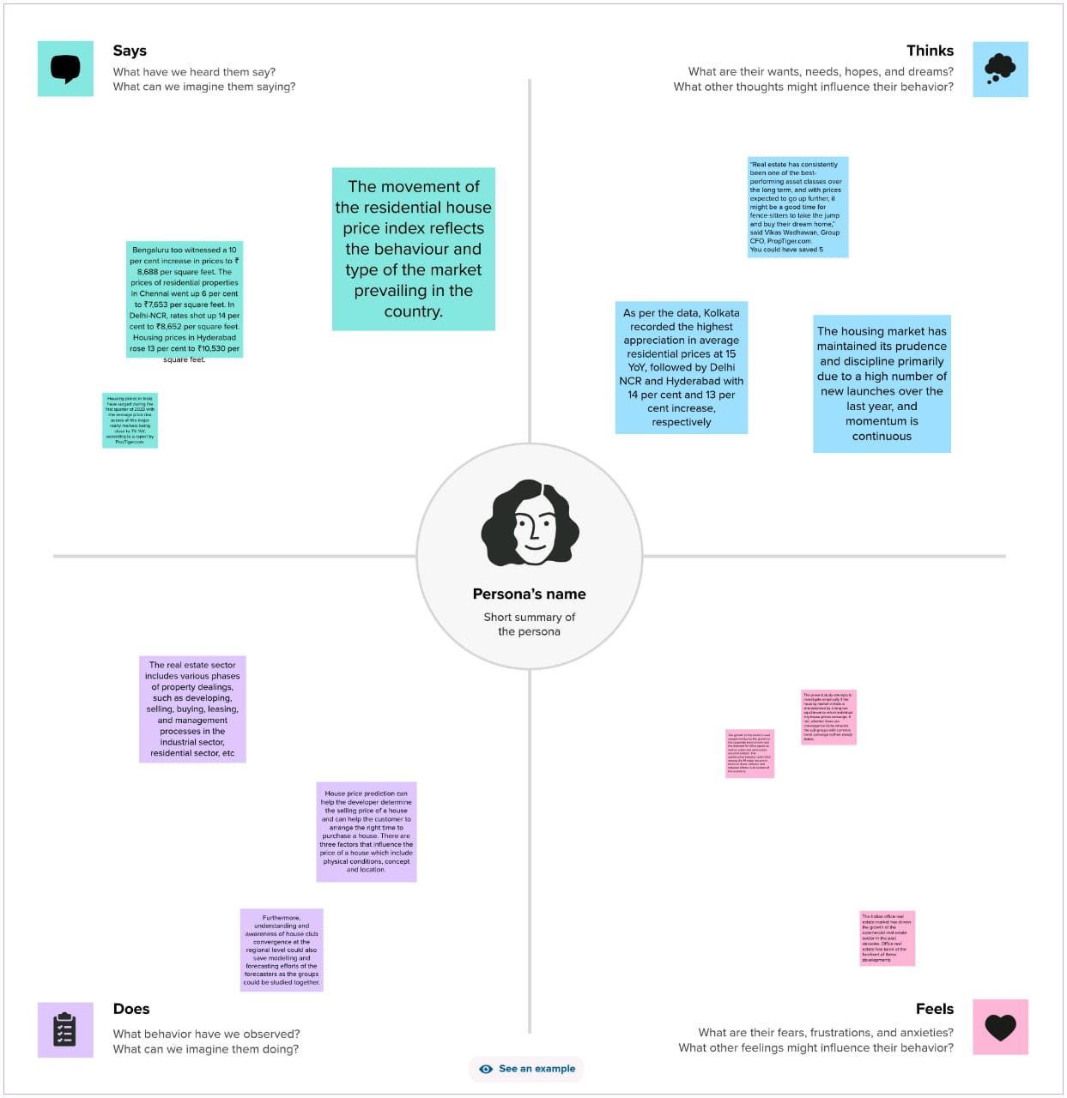

# 2.2.Ideation and Brainstorming Map:

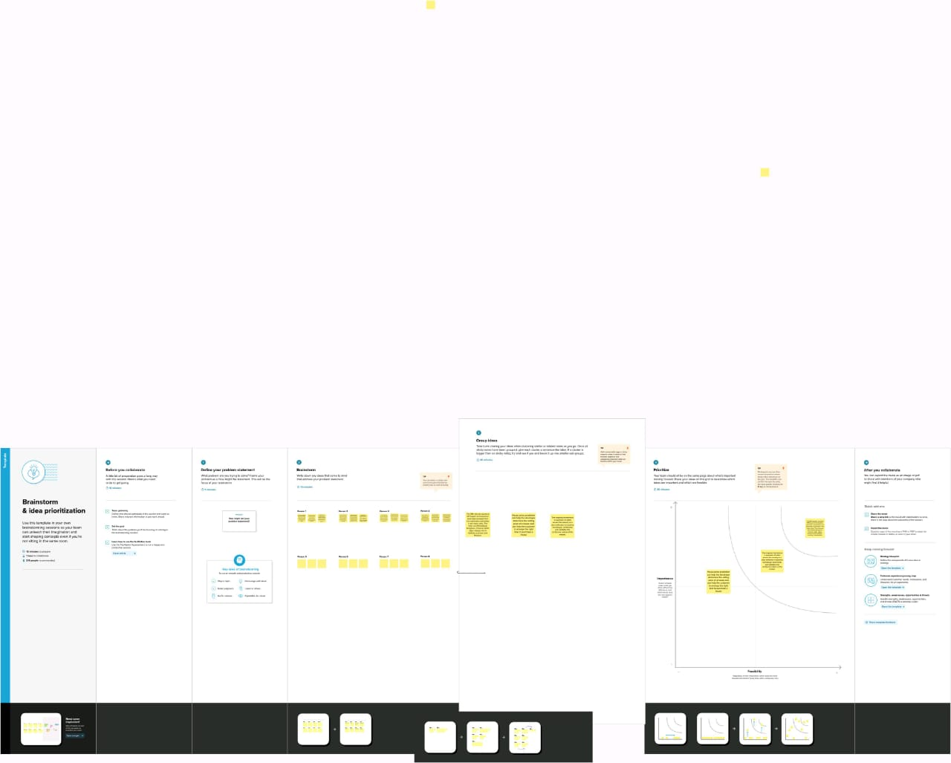

# 3.Result

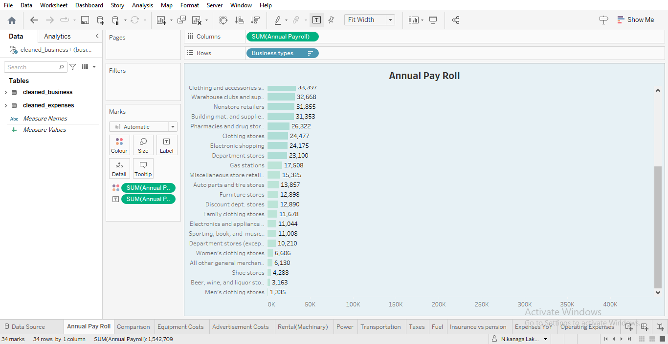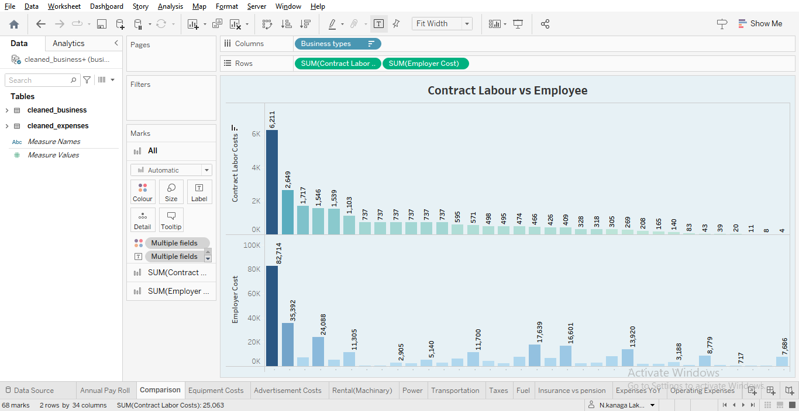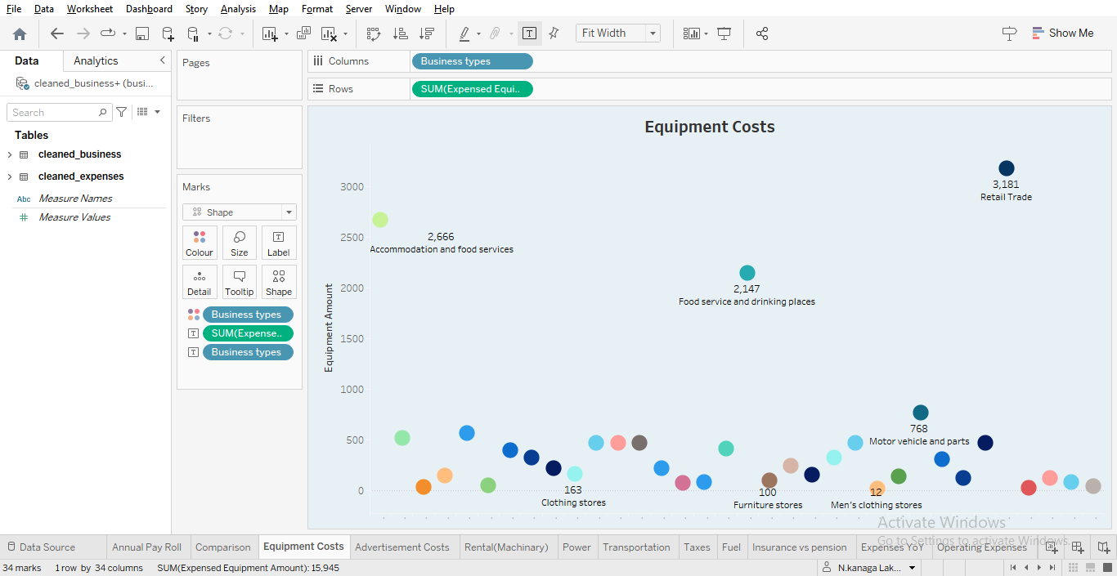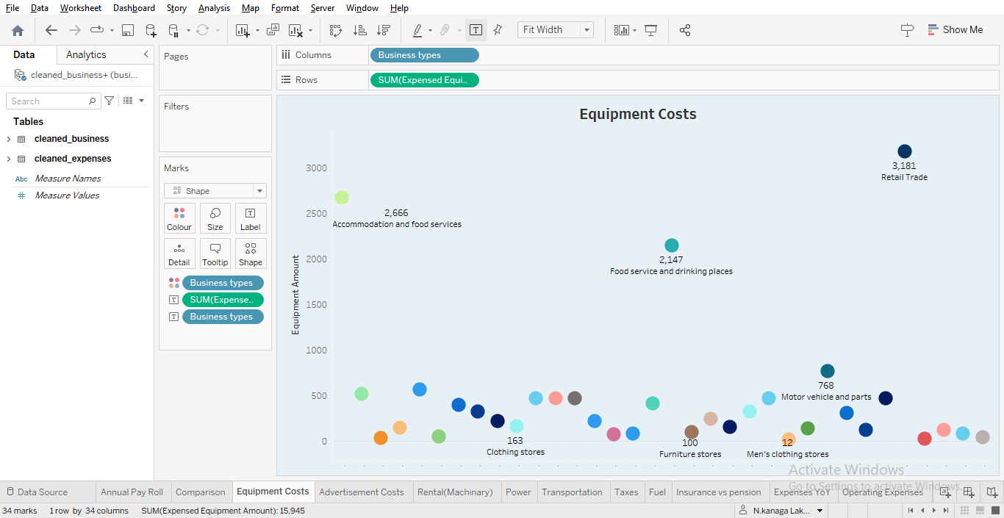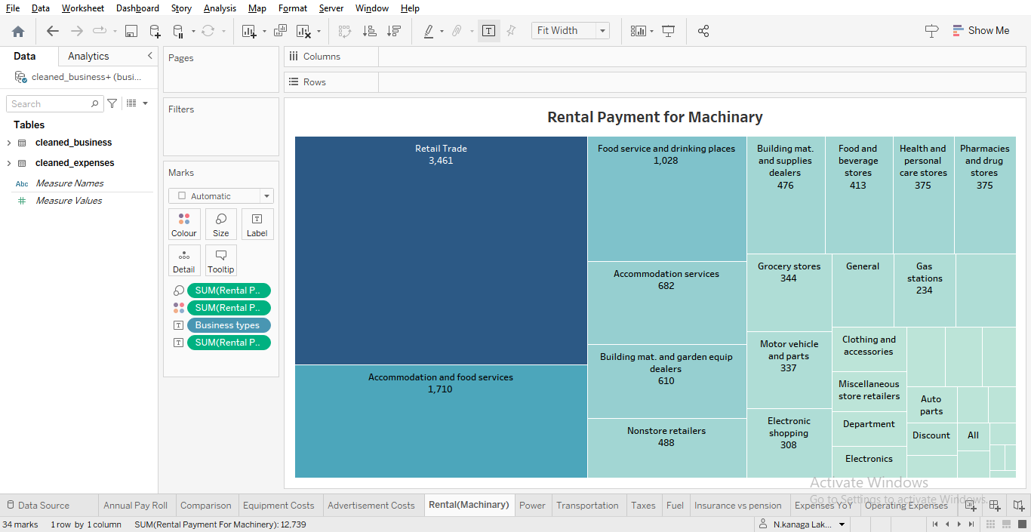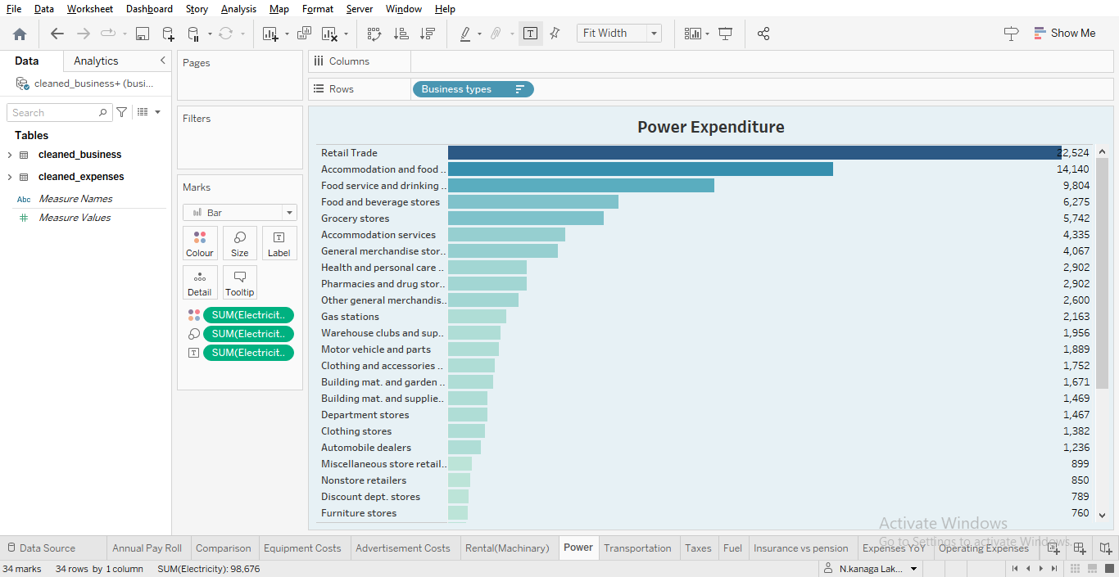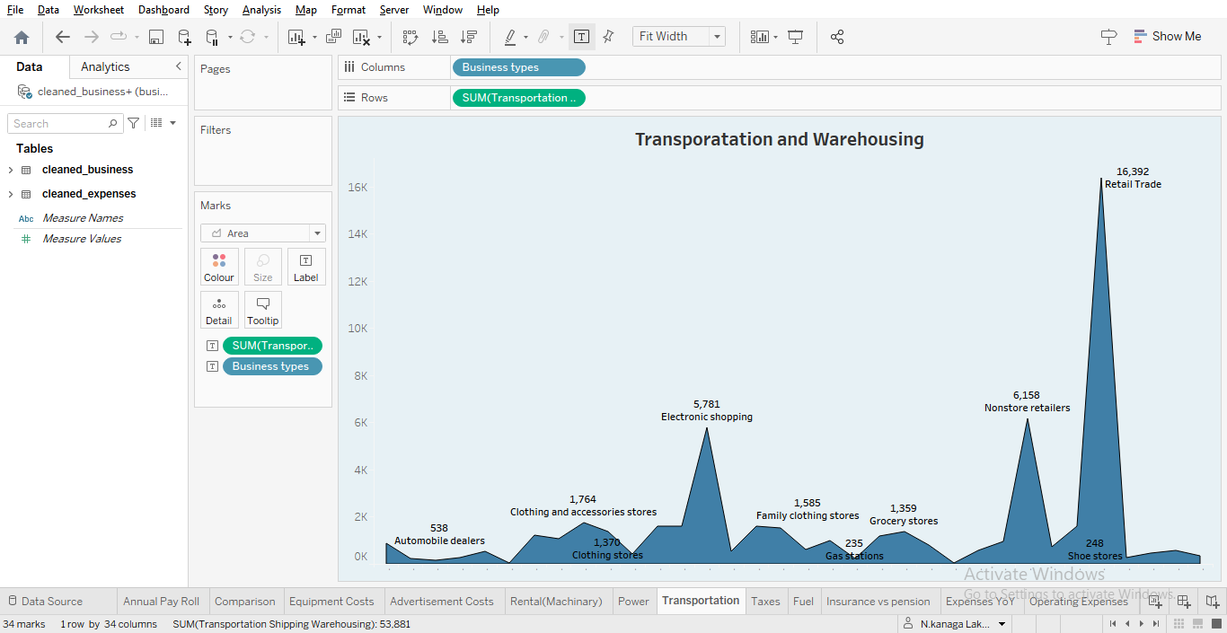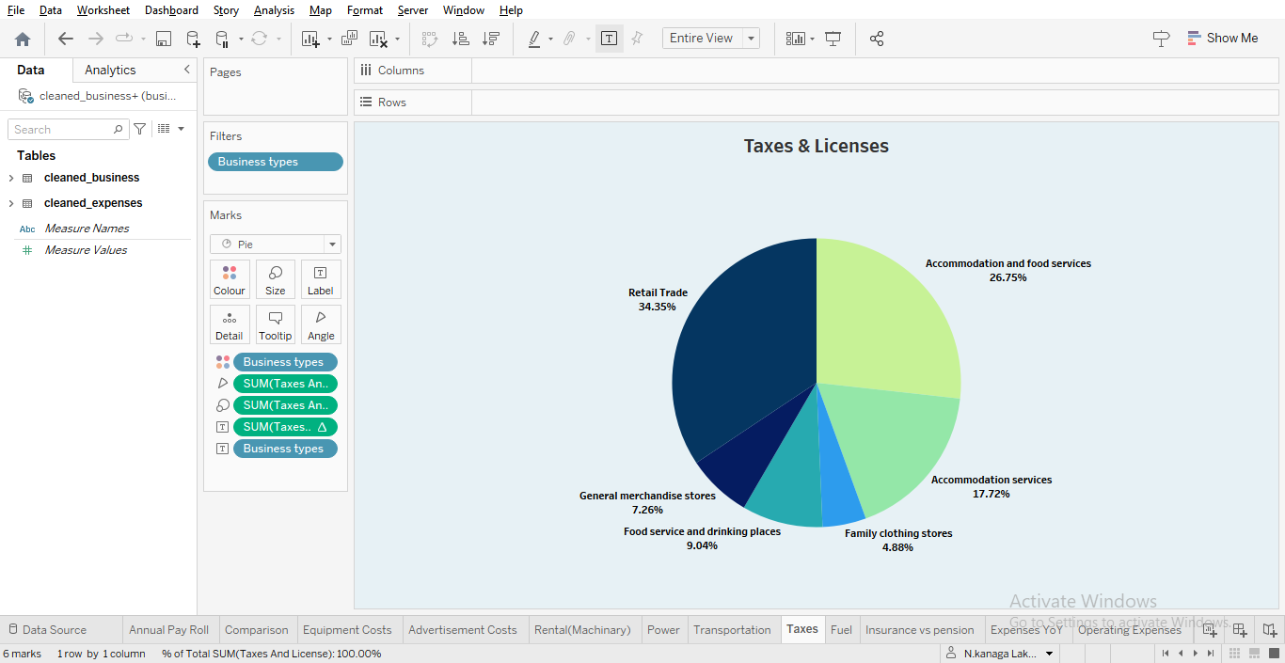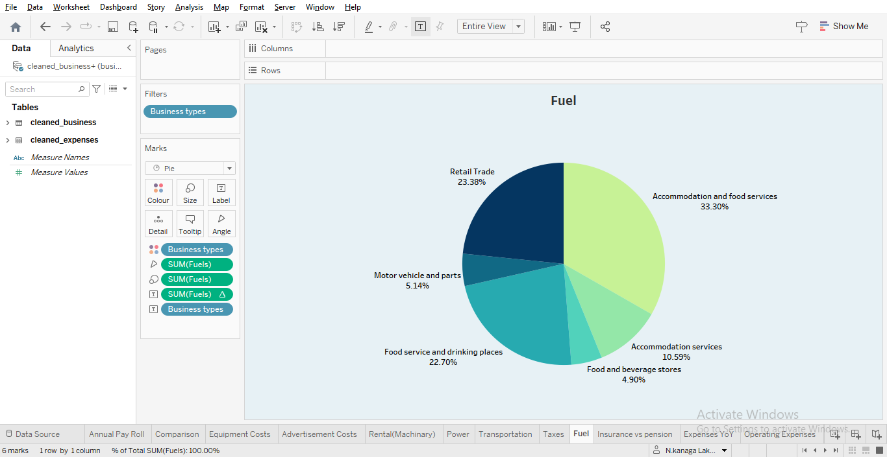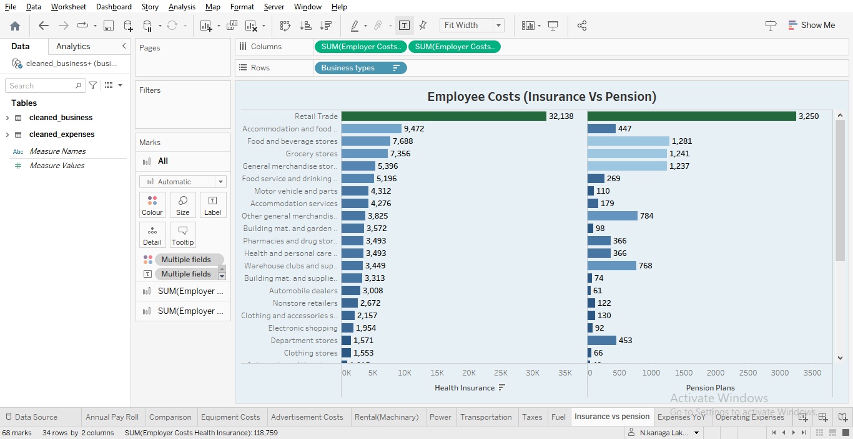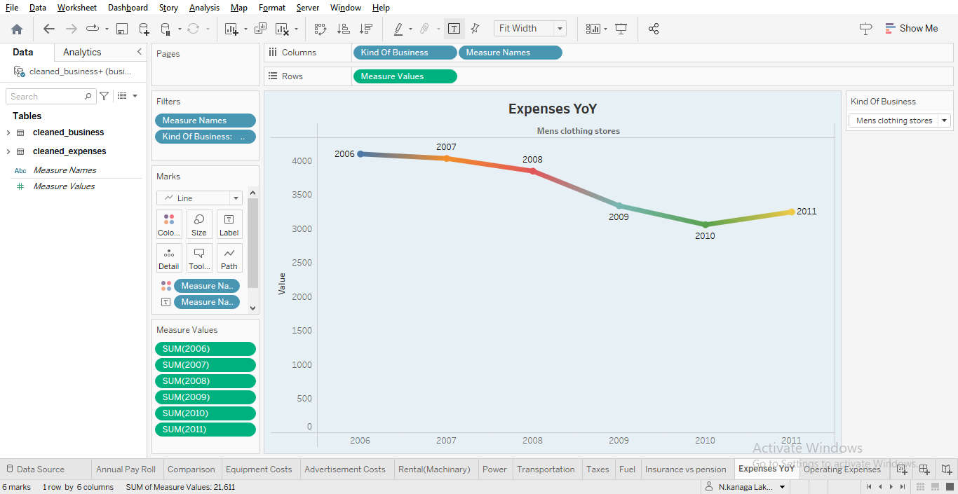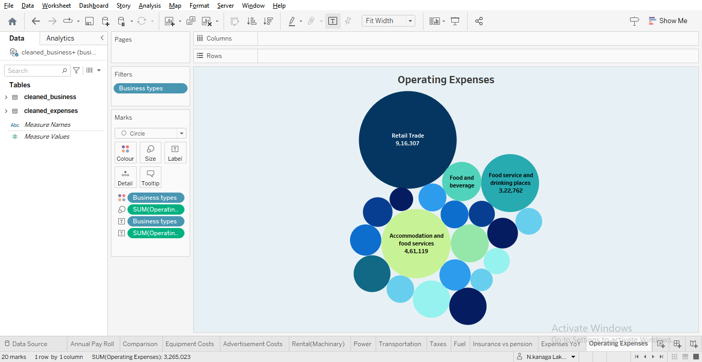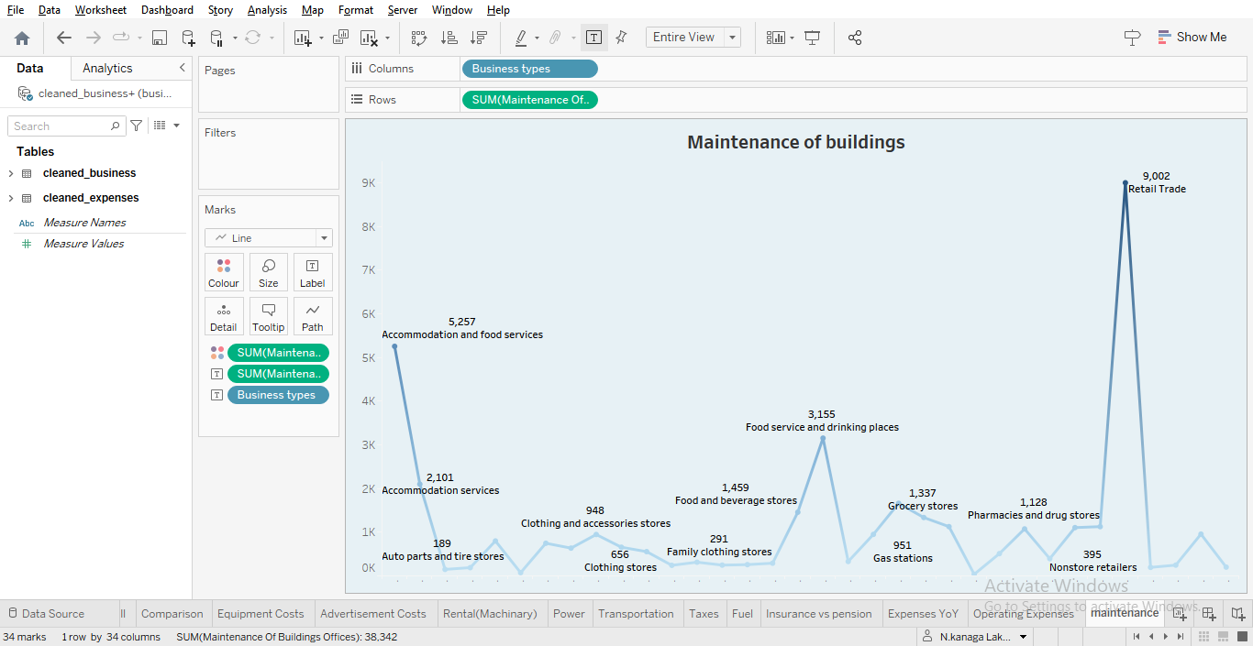

# 4.Advantages & Disadvantages

**Advantages**:

1. **Financial Planning**: Expense estimation enables businesses to create budgets and financial plans that align expenditures with expected revenues. It provides a roadmap for managing financial resources effectively.
2. **Resource Allocation**: Accurate estimation helps in allocating resources efficiently. By knowing the expected costs, companies can ensure they have the right amount of money and assets to support their operations.
3. **Informed Decision-Making**: It provides a basis for making informed financial decisions. When businesses have a clear understanding of their expected expenses, they can make strategic choices regarding investments, pricing, and growth strategies.
4. **Risk Mitigation**: Expense estimation helps identify potential financial risks and uncertainties. Businesses can plan for contingencies, set aside reserves, or implement risk management strategies to mitigate the impact of unexpected expenses.
5. **Performance Evaluation**: By comparing estimated expenses with actual expenses, businesses can evaluate the performance of different departments, projects, or initiatives. This insight aids in optimizing operations and resource allocation.
6. **Budget Control**: Accurate estimation supports budget control, reducing the likelihood of overspending or running into budgetary shortfalls.

**Disadvantages**:

1. **Inaccuracy**: Expense estimation is inherently uncertain, and it can be challenging to predict all costs accurately. Variability in factors such as market conditions and unexpected events can lead to estimation errors.
2. **Resource Limitations**: Small businesses or startups with limited financial resources may find it challenging to allocate the time and expertise necessary for accurate estimation.
3. **Over-Optimism**: In some cases, businesses may underestimate expenses to make their financial projections appear more favorable. This can lead to underbudgeting and financial difficulties.
4. **Complexity**: Accurate expense estimation can be a complex process, particularly for organizations with a wide range of expenses, complex financial structures, or rapidly changing environments.
5. **Changing Variables**: Variable costs, which can be challenging to predict, can significantly impact the accuracy of expense estimation. Market volatility, inflation, or fluctuations in demand can make it even more difficult to estimate costs.
6. **Time-Consuming**: Creating detailed and accurate expense estimates can be time-consuming. It requires data collection, analysis, and ongoing monitoring.
7. **Stakeholder Expectations**: Stakeholders, such as investors or lenders, may have high expectations based on estimated expenses. Failing to meet these expectations can have negative consequences.

# 5.Applications

1. **Budgeting**: Expense estimation is central to the budgeting process. Businesses create budgets based on estimated expenses to plan for the allocation of financial resources. This is crucial for ensuring that expenses do not exceed available funds.
2. **Financial Planning**: Estimating expenses is a fundamental aspect of financial planning. It enables businesses to project their financial needs and ensure they have the capital required to support their operations, investments, and growth strategies.
3. **Profit Margin Analysis**: Accurate expense estimation is vital for analyzing profit margins. It helps businesses assess the cost of goods sold (COGS) and operating expenses, allowing for better pricing strategies and profitability assessment.
4. **Business Valuation**: When determining the value of a business, investors and potential buyers consider the accuracy of expense estimation. It plays a significant role in assessing the company's financial health and future earning potential.
5. **Investor and Lender Relations**: Investors and lenders often require detailed financial projections, including expense estimates, as part of their due diligence. Reliable estimates help build trust and secure financing.

# 6.Conclusion

In conclusion, estimating business expenses is not just a financial necessity but a strategic imperative for any organization. It serves as the foundation for effective financial planning, informed decision-making, and overall operational success. Accurate expense estimation empowers businesses to set budgets, allocate resources efficiently, and adapt to changing market conditions.

The advantages of expense estimation include the ability to create budgets, allocate resources wisely, evaluate profitability, and manage cash flow effectively. It's also crucial for building investor and lender trust, conducting risk management, and facilitating strategic decision-making.

However, there are challenges associated with expense estimation, such as the inherent uncertainty and complexity involved in predicting all costs accurately. Variable expenses and changing market conditions can further complicate the process.

# 7.Future scope

The future scope for estimating business expenses holds significant potential for innovation and development. As technology continues to advance and the business landscape evolves, several trends and areas of focus are emerging:

1. **Advanced Data Analytics**: The future of expense estimation lies in harnessing the power of big data and advanced analytics. Businesses will increasingly use data-driven insights to refine their expense estimation models. Machine learning and artificial intelligence will play a key role in improving accuracy by identifying patterns, anomalies, and correlations within vast datasets.
2. **Real-Time Expense Tracking**: Businesses are moving towards real-time financial monitoring and reporting. This enables more accurate expense tracking and helps organizations make immediate adjustments to their budgets based on actual spending patterns.
3. **Predictive Analytics**: Predictive analytics will become more prevalent in estimating business expenses. By analyzing historical data and external factors, businesses can anticipate future expenses more accurately and proactively plan for them.
4. **Automation**: The automation of expense estimation processes will continue to gain traction. Businesses will rely on software and algorithms to handle routine estimation tasks, reducing the potential for human errors and enabling finance teams to focus on more strategic aspects of financial management.
5. **Blockchain Technology**: Blockchain can enhance expense tracking and verification by providing a secure and immutable ledger for financial transactions. This technology can improve transparency and reduce the risk of fraud in expense estimation.
6. **Cost Management Software**: The development of sophisticated cost management software will simplify expense estimation and budgeting for businesses. These tools will offer comprehensive features for tracking expenses, generating reports, and forecasting future costs.